Nepal College of Information Technology
Assessment Fall 2015

Program : BE CE/ELX Time : 3 hrs
Semester : Fall FM : 100
Subject : Basic Electrical Engineering PM : 45

- Candidates are requested to give their answer as far as practicable in their own words.
- The figure in the margin indicates the full marks
- Attempt ALL question

1.(a) Find equivalent resistance across terminals A-B for the circuit given below and calculate total current flowing through it. (8)
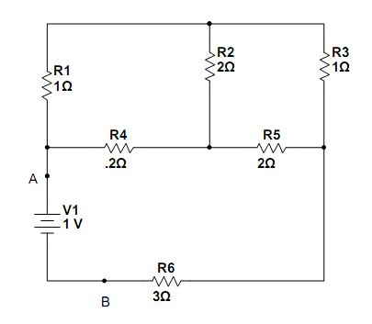ͦ
(b) State and explain maximum power transfer theorem with necessary derivation. (7)
2. (a) Determine the voltage across 3KΩ resistor using mesh analysis for the circuit shown below. (8)
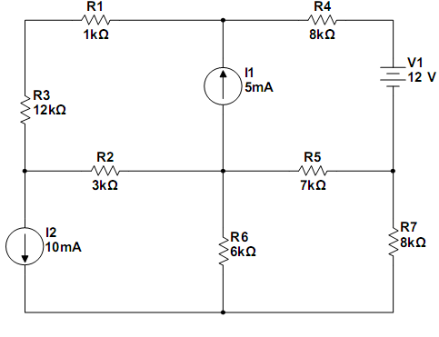
(b) For the circuit shown in figure, find the current through 15Ω resistor using Thevenin’s theorem. (7)
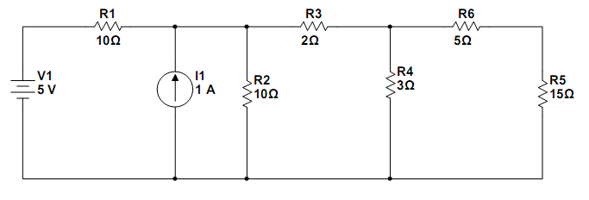
3.(a) Find the average value, rms value and form factor of given waveform. (7)
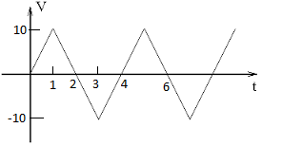
(b) The circuit having two impedances in parallel is connected to a single phase ac supply as shown in figure. The total current drawn by circuit is I= (10+j0) A. (8)
- Find each branch current, both magnitude and phase.
- Supply voltage and Power factor of circuit
- Active and Reactive power of entire circuit.
- Draw phasor diagram.

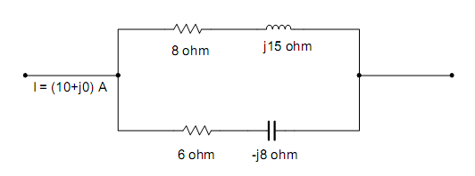
4.(a) A series R-L-C circuit has 10 Ω resistance, 0.01H inductance, and 100μF capacitance. A 100 V supply with variable frequency is applied to the circuit and tuned until resonance occurs. Find the resonant frequency, bandwidth, quality factor, and current drawn by circuit (magnitude and phase). (8)
(b) Explain measurement of three phase power by using two wattmeter method with necessary sketch. (7)
5.(a) A 400V, balanced Y-connected supply is connected to three equal impedances (80+j60) Ω in Y formation. Calculate phase current, line current, power factor and total power. (7)
(b) A 5KVA, 250/500 V transformer gave following test results. (8)
O.C. test : 20V; 12A; 100W; with secondary open circuited
S.C. test : 250V; 1A; 80W; with primary short circuited
Draw equivalent circuit of transformer referred with secondary side with respective circuit constants.
6.(a) A 220V dc shunt motor runs with 1000rpm with an armature current of 40 A. The resistance of armature is 0.5Ω. Calculate the value of resistance to be connected in series so that speed drops to 600rpm. (8)
(b) Explain methods of speed control of dc motors with neat sketch. (7)
OR
Describe working principle of 3 phase induction motor
7. Write short notes on following (Any Two) (2 x 5)
- Disadvantages of low power factor.
- Ideal and Practical sources
- Dc motor working principle.

